HeyoPhone: Onboarding experience enhancement

**XD Design:** <https://xd.adobe.com/view/3a8065c4-cd9b-4ea3-9ead-5e0a4b2b228f-6fd3/screen/57dfe4e6-26a1-40c1-ae3e-2ed90f17e867>

*(OPTION 2)*

# Purpose

The number of installations of the Heyo mobile app has increased but the number of signups is really low. This document will cover the steps to improve the onboarding experience of the customer

The onboarding module includes the following screens:

1. Fire-up
2. Get phone number and OTP
3. Business information extraction
4. KYC
5. DID/Heyo number Activation

***NOTE: Content is shared in the XD design, exact same content has to be used***

**Flow Signup**:

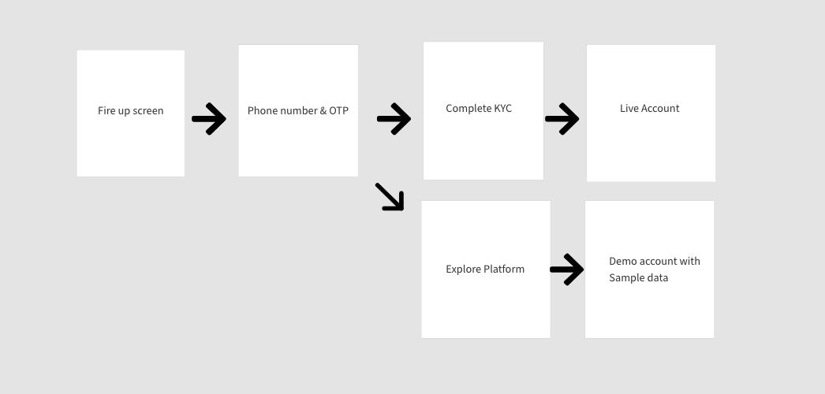

**Flow Login**:

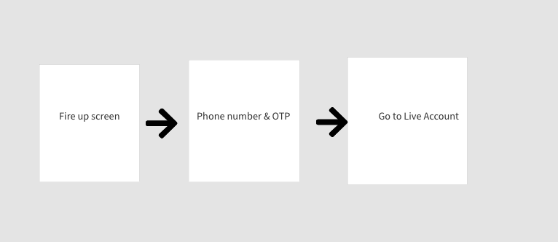

## **User story 1**: FIRE-UP Screen enhancement

| **Approved By** | **Team** | **Date** |
| --- | --- | --- |
| Shruti Agnihotri | Product Team | 8th March 2021 |
|  | Tech Team |  |

**Problem:**

As per the customer conversion trend, the installation to signup ratio is 56% only. We are losing 44% of customers weekly.

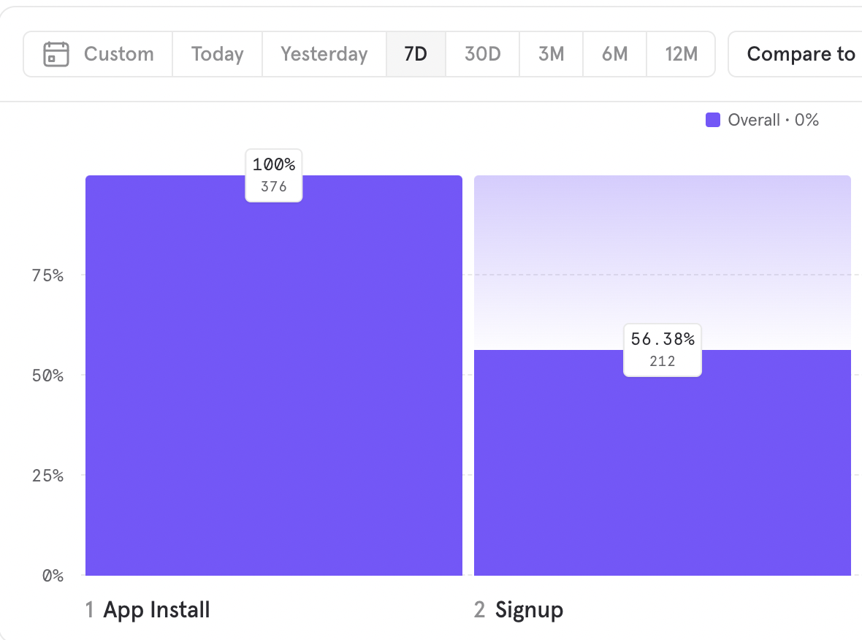

**Objective**:

To improve the number of signups, we have to enhance the customer experience. As a first step, we have to motivate the customer to enter his phone number to sign up. To achieve that, will motivate them by showing the core value propositions we are selling.

**Description:**

Add 3 images that describe the core features of the app and motivate the customer to move forward.

Note: We will keep on changing these images from time to time to keep customers engaged. Also, we will be running A/B testing on these images. The product team should be able to change the screens in the future. Please use firebase for this ( Firebase A/B Testing along with Firebase Remote Configuration services)

**Process**:

1. Put these 3 images in the carousel and play in the loop. The duration of image change is 5 seconds automatically.
2. The customer should be able to swipe right and left to see the next image.
3. There are 2 action buttons “Get Virtual number” and “login”. Both action buttons will take you to the login page.

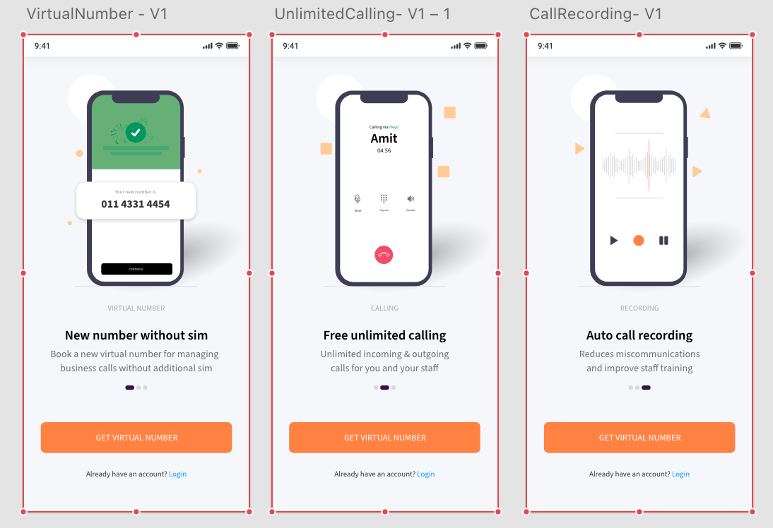

## **User story 2**: Phone number and OTP enhancement

| **Approved By** | **Team** | **Date** |
| --- | --- | --- |
| Shruti Agnihotri | Product Team |  |
|  | Tech Team |  |

Changes required on the phone number and OTP page:

1. Message change - Content is added in the XD
2. Placeholder to label transition - Remove the Label “Enter your mobile number”. Instead, add it as a placeholder, and once the customer clicks on the text field, move the placeholder up as a Label
3. Add Static +91 before the mobile number text field.
4. Improve the readability of the text by increasing the overall font size on the page, refer to XD for the size
5. Change OTP resend now to “Receive OTP via call”. The timer of 30 sec will start once the link is clicked
6. Remove popup on success “OTP success call” popup.

Success message in green color: Call initiated for OTP (remove it in 30 seconds or when a customer starts entering OTP, whichever happens first)

Error message in red color: Calling failed! Please try again (Remove it if “receive OTP via call” is clicked)

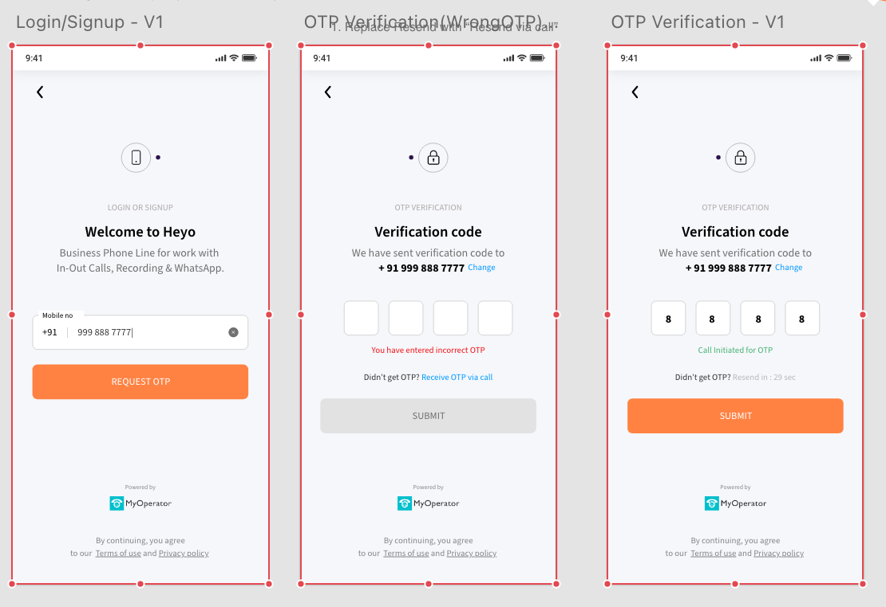

1. On clicking on: Terms of use and privacy policy: open a link <https://www.heyophone.com/terms-of-use>

<https://www.heyophone.com/privacy-policy>

## **User Story 3**: KYC & Explore now screen

**Purpose**: KYC is a mandatory process to activate the HEYO number but at the same time, customers are not comfortable doing KYC until they are confident about the mobile app.

Therefore, exploring the platform before KYC plays an important role.

On the other hand, if we skip the KYC screen and take the customer directly to the logs section of the Heyo app, he will get confused about whether it is his own data or sample data. Also, if somebody is coming through reference and willing to complete KYC and use our number, we should not force him/her to explore the platform first.

Therefore, giving them two options is important.

1. Complete KYC: To get a new number
2. Explore platform: Explore with sample data

This way the customer is aware that he is skipping the process and to use the platform, he will have to complete the KYC process in order to get a new number for his business

**Process**:

There will be two options:

1. Complete KYC to get a new number
2. Skip and explore the platform with Sample data

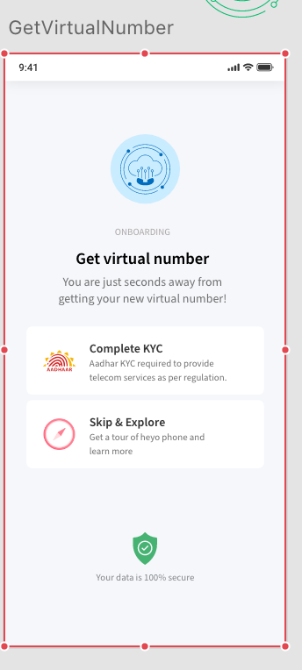

## **User story 4**: KYC

| **Approved By** | **Team** | **Date** |
| --- | --- | --- |
|  | Product Team |  |
|  | Tech Team |  |

**Problem**:

Another reason for dropping the signup ratio is, we are extracting too much information from the customer during signup and why we are taking this information is not clear to the customers.

**Objective**:

Our objective is to reduce the onboarding steps and allow customers to quickly jump to the platform without much effort.

**Process:**

Old process: There were 2 pages, Business information & a setup KYC page to activate the HEYO number.

New Process: We will combine 2 pages into 1 and also reduce the number of fields that need to be filled. The new Setup KYC page will include

1. **Business Name**: Text field > This is a Mandatory field to set up an account. We will display this business name in the settings section also. This is a primary field to create an account. Max characters limit should be 50 and the minimum limit can be 3 characters
2. **Select City**: Dropdown > City is important is assign the HEYO number to the customer. We are assigning landline numbers as a Heyo number. The **city** field helps us determine the STD code to be added before the number. The technical team will pick the number from the number pool based on the city selected. For example, if Delhi is selected, the number will start with 011, In the case of Noida, it is 012, and so on.

Show available cities only. Additionally, Remove **notify me**.

1. **Aadhar number**: As per telecom guidelines, aadhaar verification is mandatory before assigning a number to the client.

**The outcome of this process**: Heyo number will be assigned to the customer

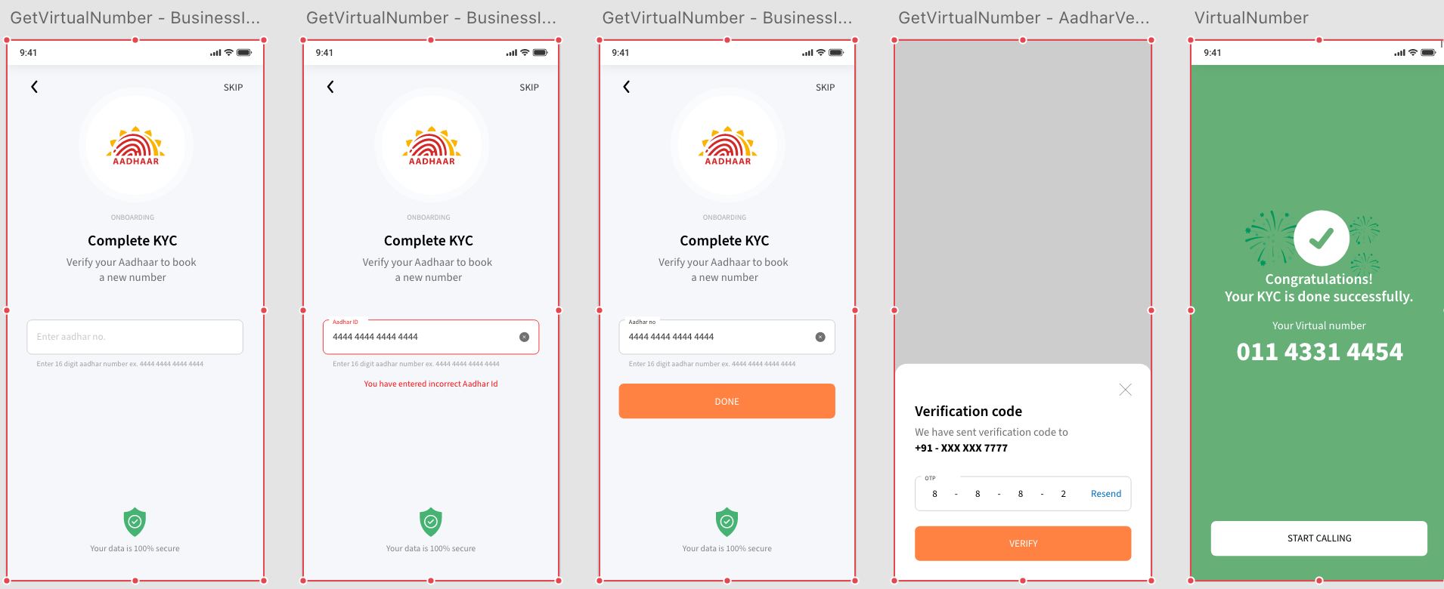

## **User story 5**: SKIP & EXPLORE

| **Approved By** | **Team** | **Date** |
| --- | --- | --- |
|  | Product Team |  |
|  | Frontend Team |  |
|  | Backend Team |  |

**Problem**: Right now, we are forcing customers to fill out all the forms before exploring the platform.

This is one of the main reasons for the drop in the conversion rate. People don’t feel confident in filling in their information before exploring the platform

**Solution**: Introduction of skip & explore feature before KYC. This will allow customers to explore the feature sets, play around with the platform before making a purchase.

**DUMMY Info will be displayed in settings:**

Business Name: Heyo Phone Demo

City: Delhi

**Process:**

Once the customer clicks on skip & explore, take him into the app > Logs section

**1 . LOGS**

**What will work**

* + We will be providing a few dummy logs
  + Dummy logs will be clickable > We can see the log detail and history also
  + Log search
  + Three dots
  + Open Whatsapp>show integration page

**What will not work**

* + Call action button will not work> Show KYC popup
  + Open Whatsapp>show integration page>on clicking on verify show KYC popup

2. **WHATSAPP BUSINESS**

**What will work**

* + Open integration page

**What will not work**

* + On clicking on verify button, open the KYC popup

Note: This process is the same for all WhatsApp buttons

3. **CONTACTS**

**What will work**

* + Fetch and show actual contacts
  + contact search
  + Three dots
  + Open Whatsapp>show integration page
  + Add Contact

**What will not work**

* + Call action button will not work> It will take the customer to the KYC page
  + Open Whatsapp>show integration page>on clicking on verify show KYC popup

4. **SETTINGS**

**What will work**

* + Availability on/off : Just the on-off toggle will work at the front end
  + Logout
  + Show business name

**What will not work**

* + Configure phone line > Open KYC popup
  + Configure Whatsapp > Open KYC popup
  + Support > Open KYC popup
  + Availability on/off> Do not hit any API in the back end

4. **DIALLER**

**What will work**

* + Type number
  + Paste number

**What will not work**

* + Call action button will not work> It will take the customer to the KYC page

POPUP MESSAGE to setup KYC:

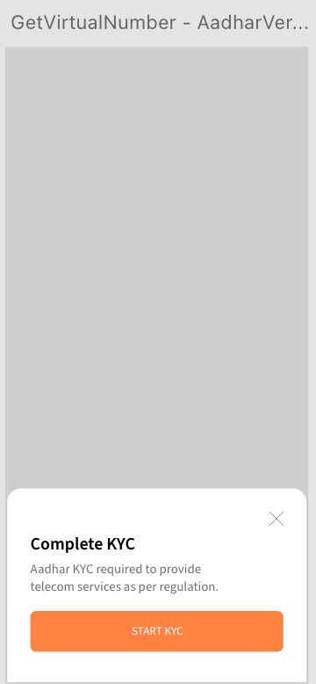

DUMMY DATA LOGS XD: <https://xd.adobe.com/view/9dd69903-92b5-4380-b1dd-7b9ffcaa384f-c885/?fullscreen>

Changes from version 1 to version 2:

**In version 1**, we had one page to gather business information and another page to complete KYC

Business information page includes:

1. Business name
2. EmailId
3. Location: Available location and coming soon locations + “Notify me” capability

KYC page includes:

1. Business Type
2. Business legal name(for invoicing)
3. GST State
4. GSTIN
5. Billing address
6. Pincode
7. Aadhar number and verification

**In version 2,**

We have combined both these pages into 1 and the number of fields are also reduced to 3 fields

1. Business name
2. City (Location)
3. Aadhar number & verification

<https://xd.adobe.com/view/3a8065c4-cd9b-4ea3-9ead-5e0a4b2b228f-6fd3/screen/57dfe4e6-26a1-40c1-ae3e-2ed90f17e867>